

**March**

6- NICC Visit Day

9- FSQA Testing

10- Chapter Meeting

14- NE District Contest

18- National Ag Day

27- Officer Application DUE

30- ISU CALS NIGHT

**January/February**

INdependence Agriculture Education Program

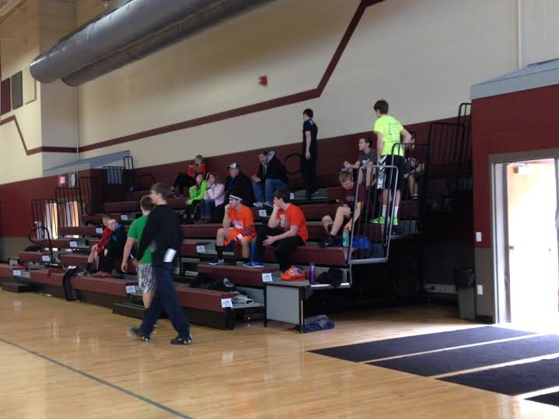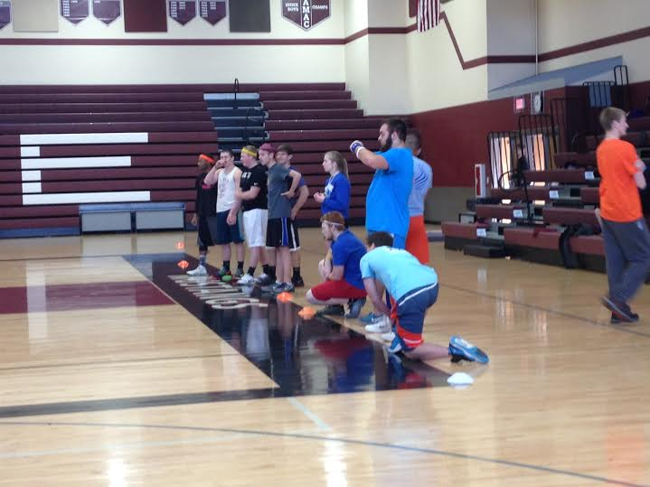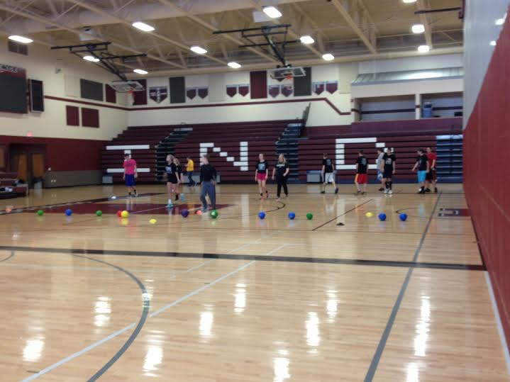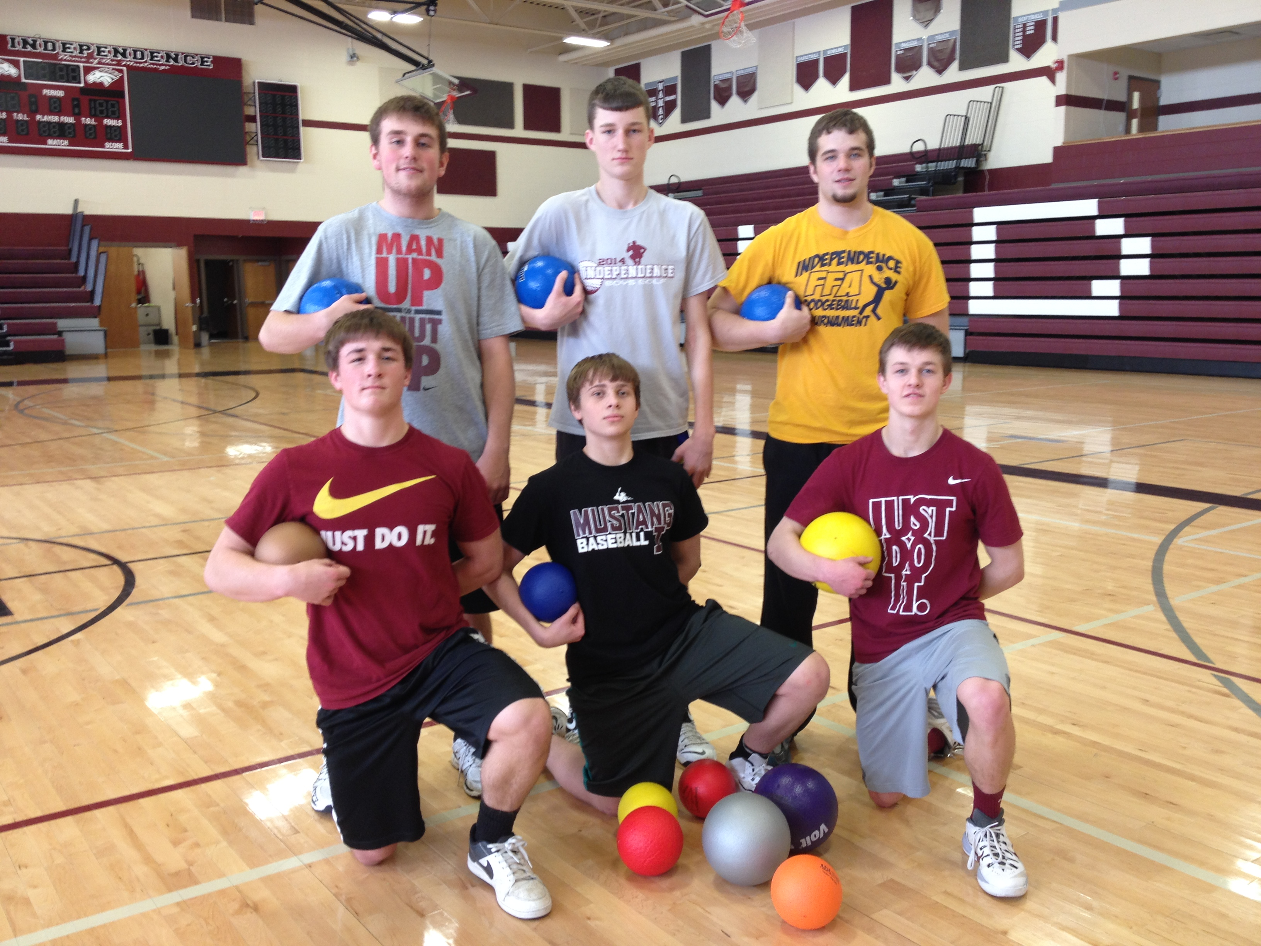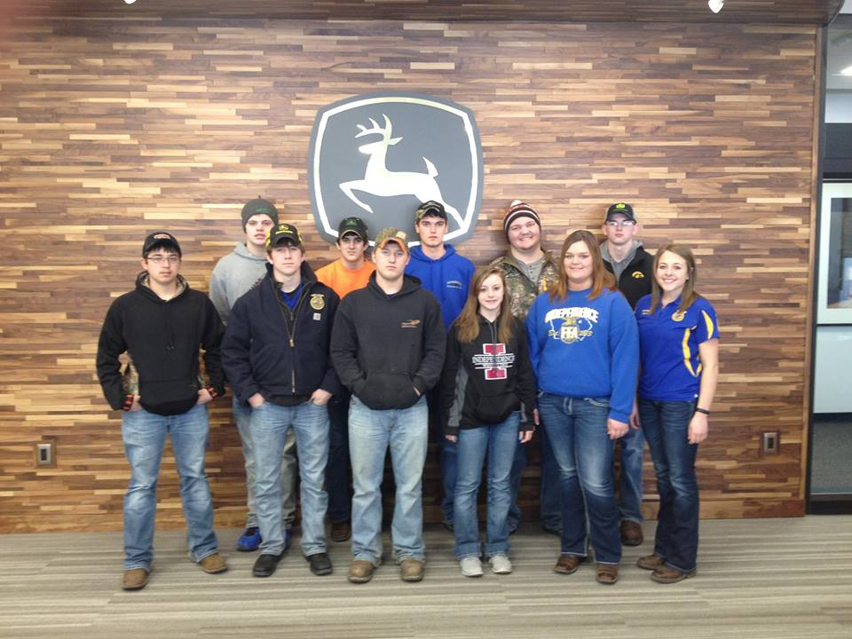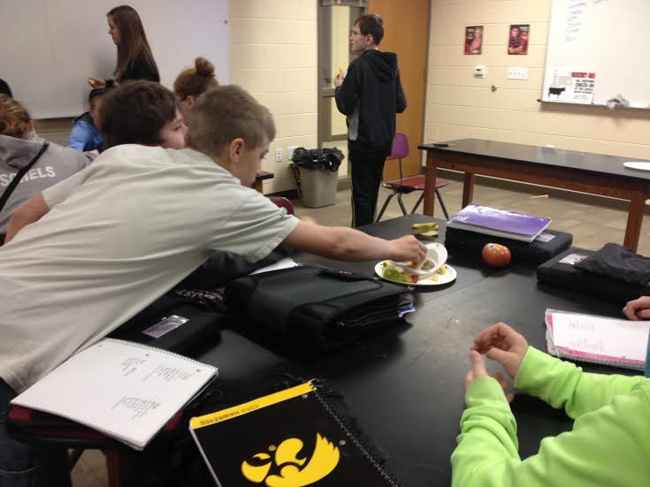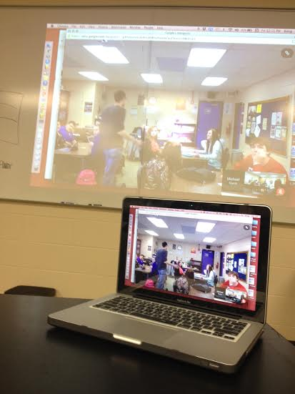

**The weather took a toll on our FFA Week plans but we made the most of it!**

**The dodgeball tournament hosted a total of 8 teams in the gym. As well as local teams, North Linn, Jesup, Gladbrook-Reinbeck and Oelwein FFA chapters were represented.**

**Thursday, FFA members and students traveled to Waterloo to tour the Tractor Works Facility.**

**The canned food drive has been extended to March 13th and subdistrict contest was postponed. Look for a report of those results in next month’s update!**



**FFA Week 2015: Go All Out!**

### Upcoming Events

**Stay up to date by visiting our website! www.agicsd.com**

If you are interested in gaining additional leadership skills joining our chapter officer team is a GREAT opportunity.

Responsibilities include:

* Attending multiple leadership trainings this summer
* Working with and leading chapter members
* Promoting FFA to the community and student body

Required deadlines should be taken VERY seriously and are listed below:

**Friday March 27th-**  Application and references due to Ms. Emig

**Sunday April 12th-** Officer Interview and Chapter Presentation Night

2015 officer team announcement will be made at our chapter banquet Sunday April 26th at the high school.

**2015 Officer Team Applications**

**ISU CALS NIGHT: March 30th**

WHO: Anyone interested in the Iowa State University College of Agriculture and Life Sciences.

WHAT: *FREE EVENT and DINNER* Prospective Student Meet & Greet to learn about majors/curriculum, study abroad, scholarships and campus opportunities from current students and alumni

WHERE: Starmont High School

WHEN: Monday March 30th 6:00 PM \***RSVP is required- contact Emig to do so\***

RS

**FSQA Testing- March 9th**

If you are planning to exhibit a production oriented animal at the county or state fair level this summer, Food Safety and Quality Assurance (FSQA) is REQUIRED! To meet that requirement permanently taking a test is an option. On **March** **9th** (no school day) a training and test day will be provided in the Ag Room at the high school. Proposed schedule below:

**9:00** Training, Practice Tests, Videos **12:00** Test Presented by Alexia H. (ISU Extension)

Our second program banquet will be held on Sunday April 26th at the Junior/Senior High School.

Look for a formal invitation to be sent in the coming weeks. Attendance is required for members, family members are encouraged to join us!

Dinner, Silent Auction and Awards Presentation will be held.

### Save the Date: April 26!

**April**

10- Hawkeye Ag Day

14- Chapter Meeting

19-21 State FFA Convention

26- Chapter/Program Banquet

This fall brings the addition of two new agriculture education courses to registration.

* Intro. to Ag.
* Plant Science
* Animal Science
* Horticulture
* Ag. Issues
* **Ag. Leadership**NEW**-

Focuses on developing personal and career development through leadership and Agricultural content (any grade level)

* **Ag. Co-Op**NEW**-

Take the opportunity to learn more about an agricultural career and earn on the job career skills. Program application and approved release from school required.

### 2015 Ag. Education Courses

**Stay up to date by visiting our website! www.agicsd.com**