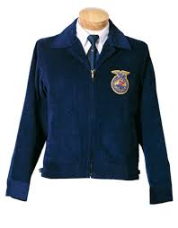

**Ready to wear the blue jacket?**

### From the Classroom

**January**

13- Chapter Meeting

24- Mustang Foundation Banquet

INdependence Agriculture Education Program

Any member interested in ordering an FFA jacket for this year must be fitted and have their order placed before this month’s chapter meeting on **January 13th.**

*Why would I need a jacket?* The FFA jacket is one piece of the official dress or uniform for FFA members. It should be worn at any formal FFA function such as contest, community event or chapter banquet.

*What is the cost to members?* Unless you earned your jacket through fruit sales, the cost for a jacket plus scarf or tie is $75. Funding sources are available for any member who would like to order a jacket but may struggle financially.

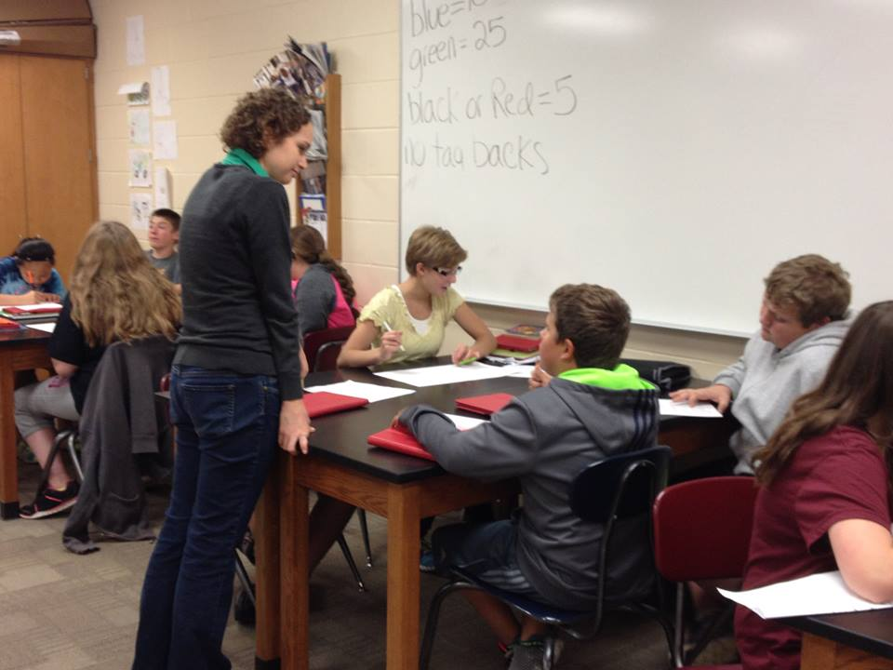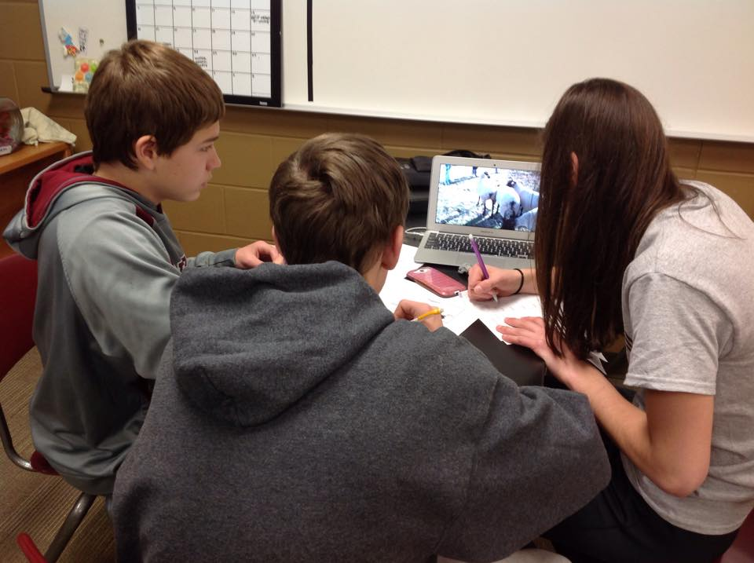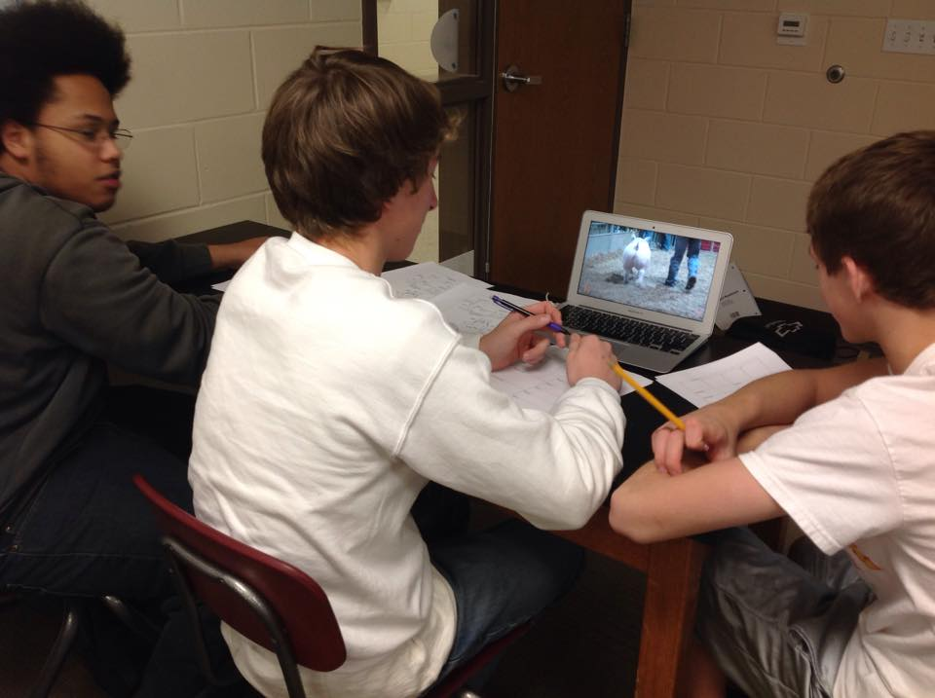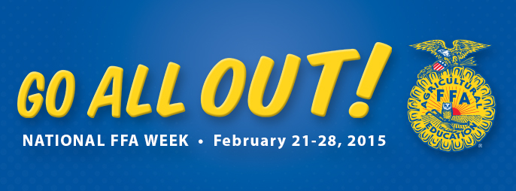

Food Safety Quality Assurance (FSQA) is a mandatory requirement for any member exhibiting market/breeding beef, swine, sheep and dairy cattle, dairy/meat goat, rabbit and poultry. Options for meeting this requirement include attending a yearly training OR completing senior test.

**Training Session Dates/Locations:** Hawkeye Community College Sat. 3/28 9-10:30 AM Farm Lab Mon. 3/30 6:30-8:00 PM 5503 Hammond Ave. Sat. 4/11 9-10:30 AM

**Testing can be done at any of the training dates listed above or at the Buchanan County Extension Office by making an appointment with Alexia- (319) 334-7161**

**\*\*This is not optional. If you are exhibiting livestock at the Buchanan County or State Fair, this must be taken care of. As always, let Ms. Emig know if there are any questions!**

**Livestock Exhibitor Requirement: FSQA**

### Upcoming Events

**December**

**Stay up to date by visiting our website! www.agicsd.com**

**Mustang Foundation Banquet**

FFA and Ag. Education will be represented at the annual Mustang Foundation Banquet (Jan. 24) by each serving a dessert.

**2-3 FFA members are needed to assist in serving and/or making a dessert.** All dollars raised will go to benefit the chapter. Let Emig know if you’re interested!

**February**

10- Chapter Meeting

22-28 National FFA Week

25- SW Subdistrict Contest

Through work in a Supervised Agriculture Experience (SAE) FFA members select a proficiency award area. This is kind of like a project category title and helps to focus the goals and accomplishments of a student’s project. Each year, a member can apply for a proficiency award in their respective area.

This year Independence FFA will be submitting 5 different applications in the following proficiency award areas:

* Beef Production- Placement
* Beef Production-Entrepreneurship
* Diversified Crop Production

### FFA Lingo: Proficiency Award

Another exciting week is being planned to celebrate National FFA Week! This is a week totally dedicated to FFA to help educate the community as well as the student body about the National FFA Organization. You can look forward too:

* FFA Dodge ball Tournament
* School wide canned food drive
* Dress-Up days
* Junior High FFA Lunch

It will soon be that time to register for courses for the 2015-2016 school year. Agriculture Education courses offer the opportunity to not only learn more about the agricultural industry, but provide growth in leadership skills and increase career readiness. For the 2015-2016 school year, two additional courses will be added to the list of options within the Agriculture Education Department.

* Introduction to Agriculture (suggested for freshmen)
* Ag Leadership**NEW
* Animal Science
* Plant Science
* Horticulture (suggested for upperclassmen)
* Ag Issues & Perceptions (suggested for upperclassmen)
* Ag Co-op/Internship**NEW (must be approved for release)

Detailed course descriptions will be given to all students with registration materials but any questions can be directed to Ms. Emig- remig@independence.k12.ia.us

**New Ag. Ed. Course Offerings**

**Stay up to date by visiting our website! www.agicsd.com**